**DevOps Project**

**Objective:** You have been Hired Sr. Devops Engineer in Abode Software. They want to implement Devops Lifecycle in their company. You have been asked to implement this lifecycle as fast as possible. Abode Software is a product-based company, their product is available on this GitHub link.

<https://github.com/hshar/website.git>

Following are the specifications of the lifecycle:

1. Git Workflow has to be implemented

2. Code Build should automatically be triggered once commit is made to master branchor develop branch.

If commit is made to master branch, test and push to prod

If commit is made to develop branch, just test the product, do not push to prod

3. The Code should be containerized with the help of a Dockerfile. The Dockerfile should be built every time there is a push to Git-Hub. Use the following pre-built container for your application: hshar/webapp The code should reside in '/var/www/html'

4. Once the website is built, you have to design a test-case, which will basically check if the website can be opened or not. If yes, the test should pass. This test has to run in headless mode, on the test server.

5. The above tasks should be defined in a Jenkins Pipeline, with the following Job

1 - Building Website Job

2 - Testing Website Job

3 - Push to Production

6. Since you are setting up the server for the first time, ensure the following file exists on both Test and Prod server in /home/ubuntu/config-management/status.txt. This file will be used by a third-party tool. This should basically have the info whether apache is installed on the system or not The content of this file, should be based on whether git is installed or not.

If apache is installed => Apache is Installed on this System"

If apache is not installed => "Apache is not installed on this System"

7. Create a Monitoring Service for the website on the Production server

Architectural Advice:

Create 3 servers on AWS "t2.micro"

Server1 - should have Jenkins Master, Puppet Master and Nagios Installed

Server 2 - Testing Server, Jenkins Slave

Server 3 - Prod Server, Jenkins Slave

Creation of servers in AWS for master, test and production environment

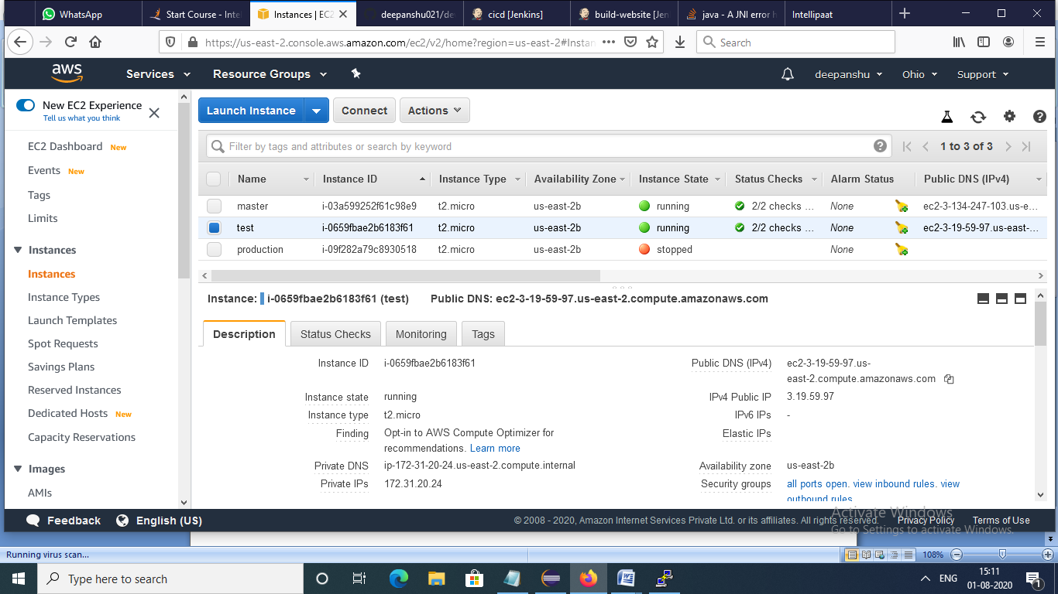

Master server

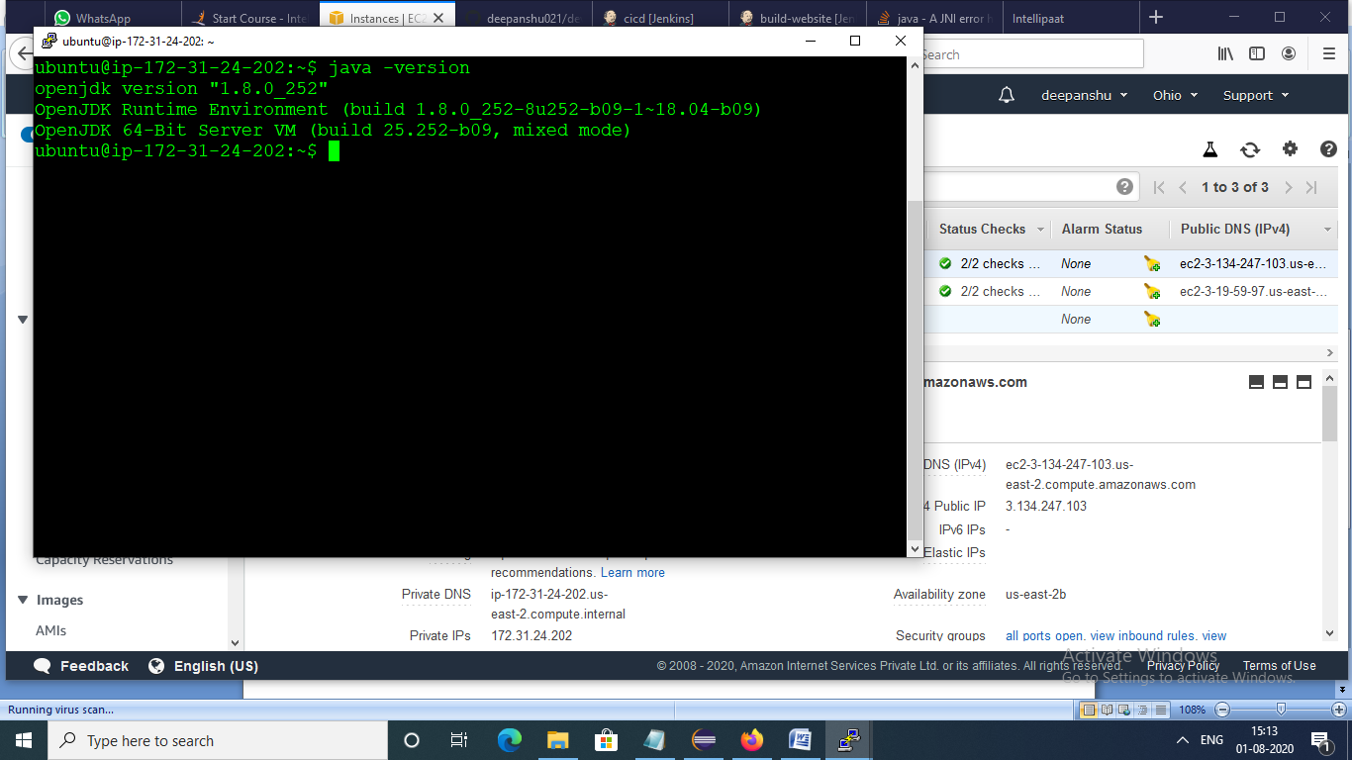

Testing server

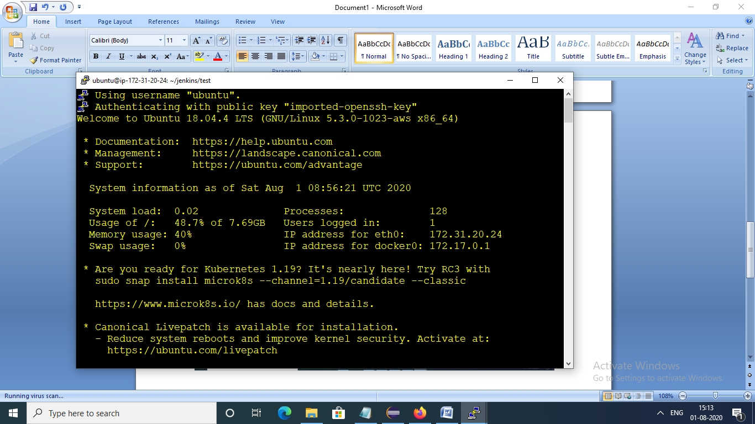

Installation of java Jenkins and docker on master as well as testing server

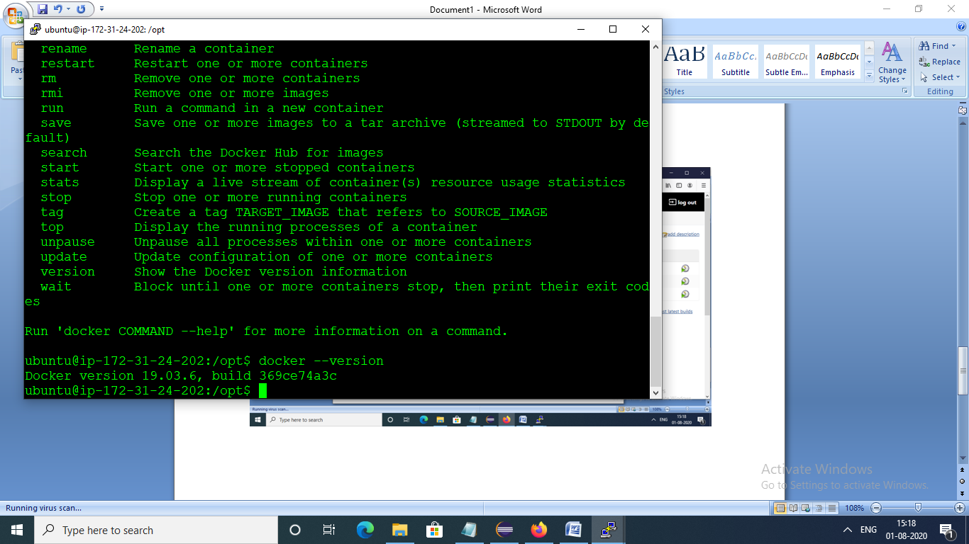

Testing server with connection with Jenkins and chrome driver installed and with git initialized with jar file

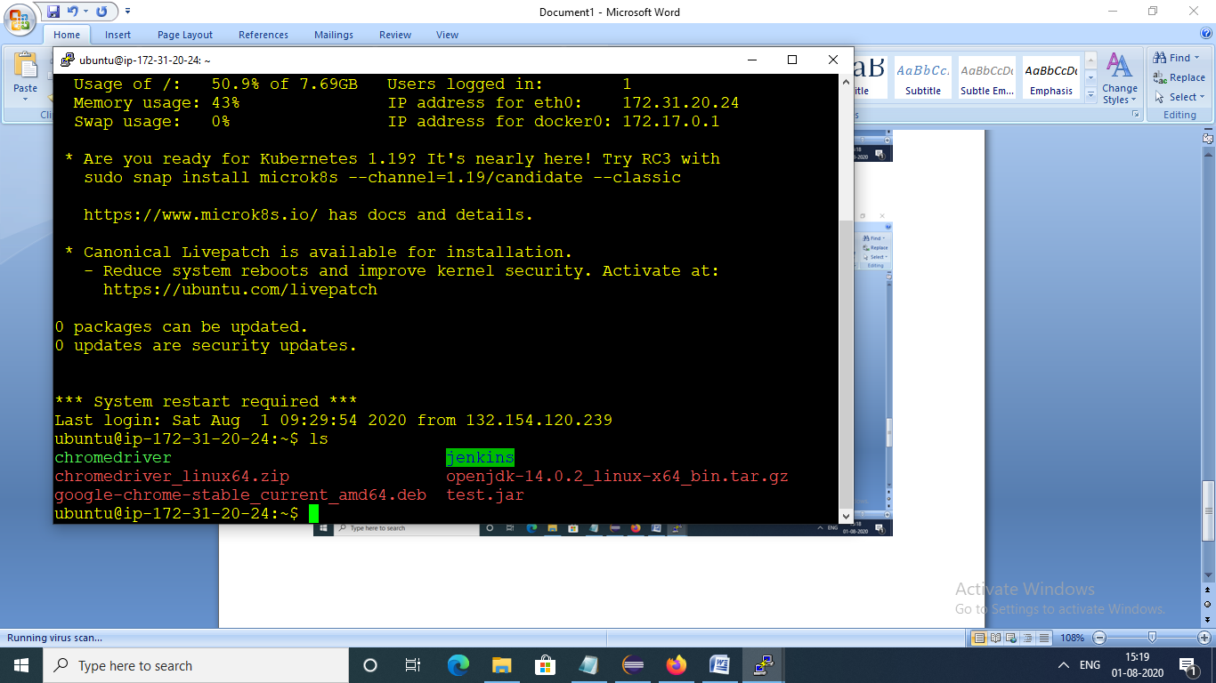

Node connection in jenkins

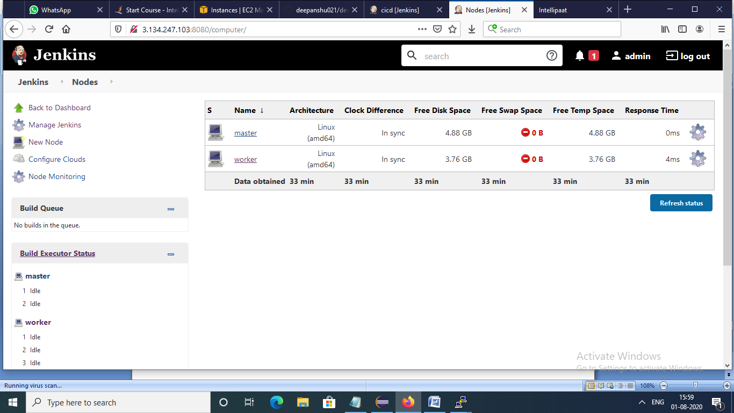

All files in testing server

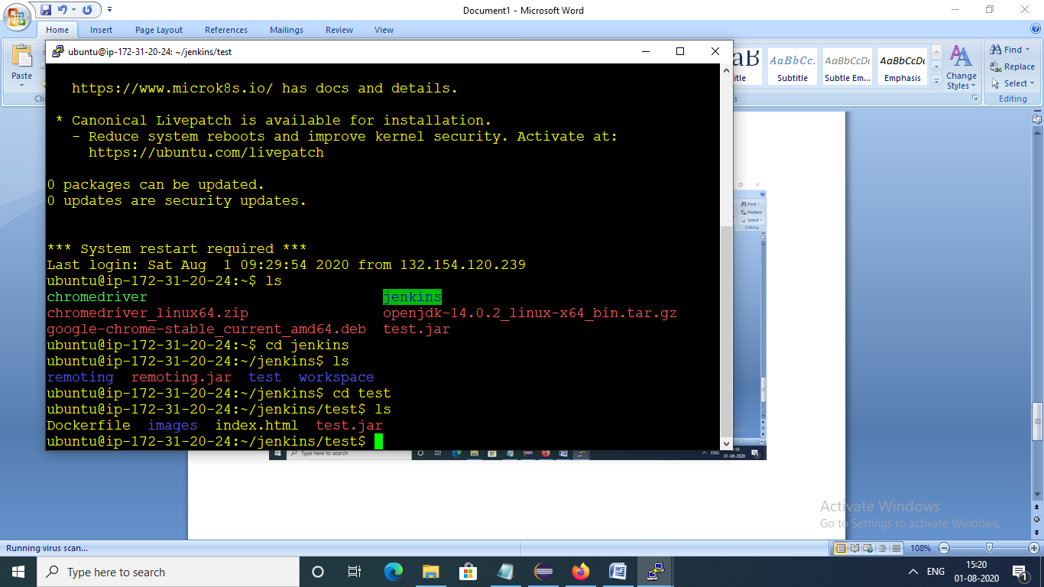

Successful builds in jenkins

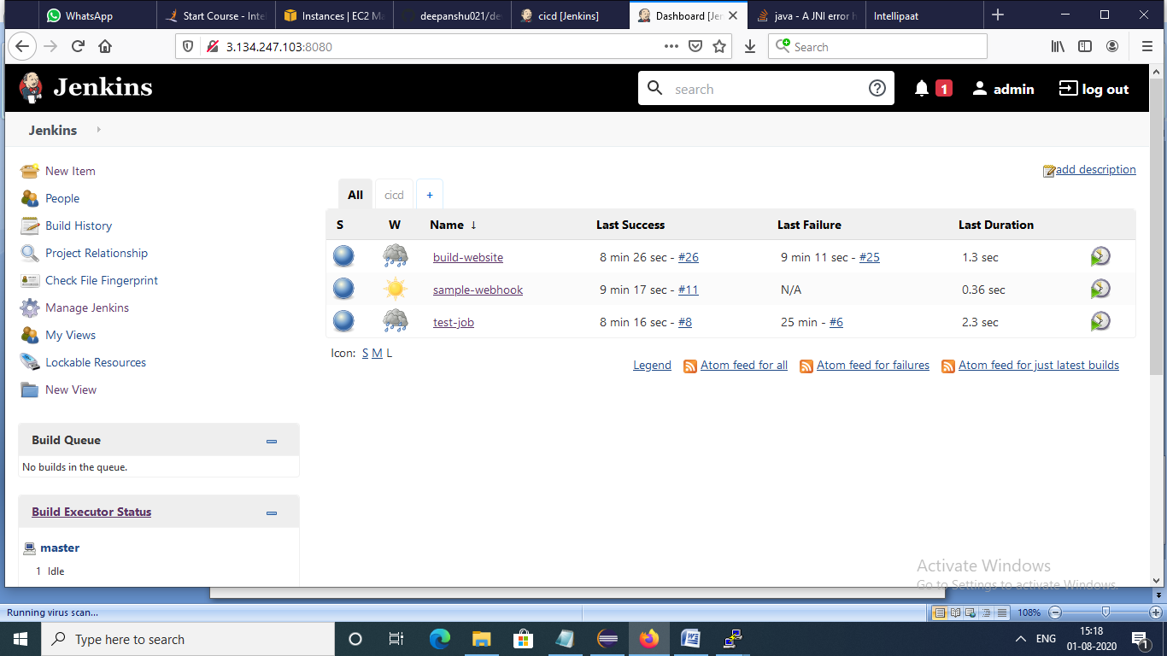

Configuration of node in Jenkins which connected using SSH

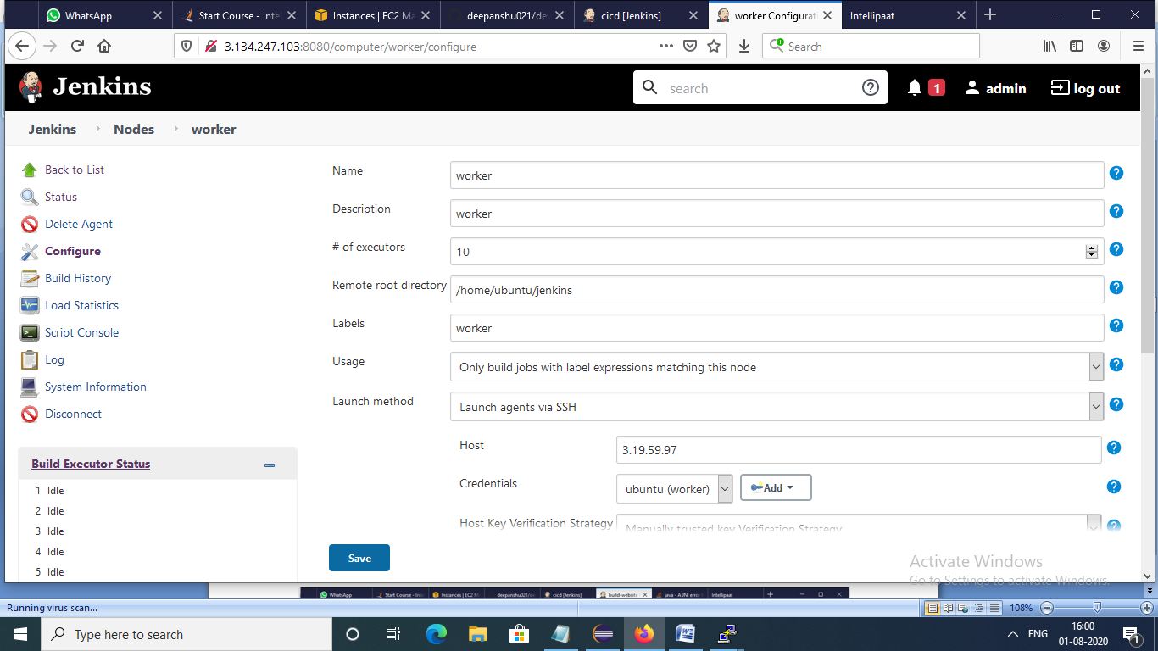

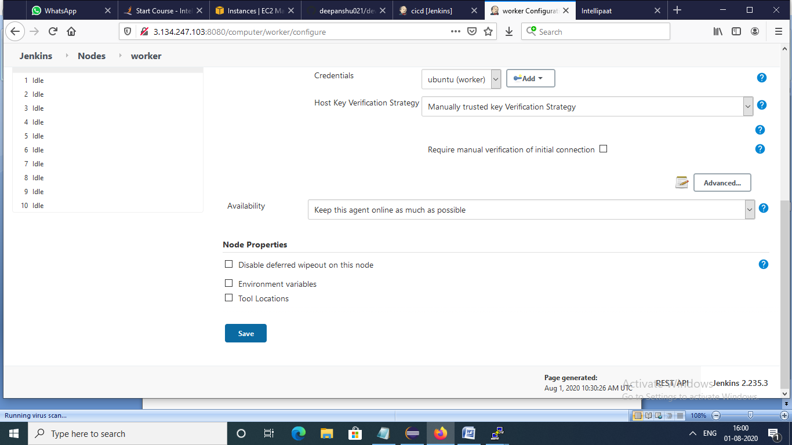

Configuration of build – build-website

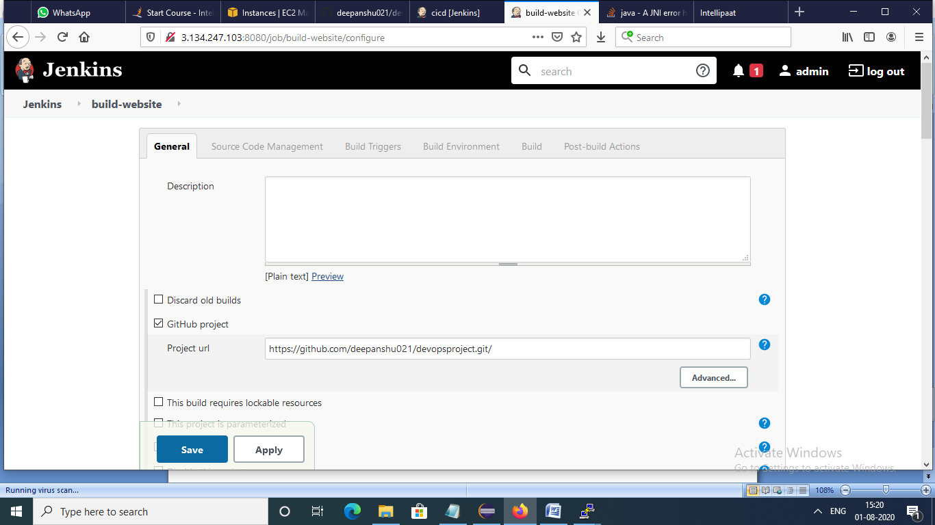

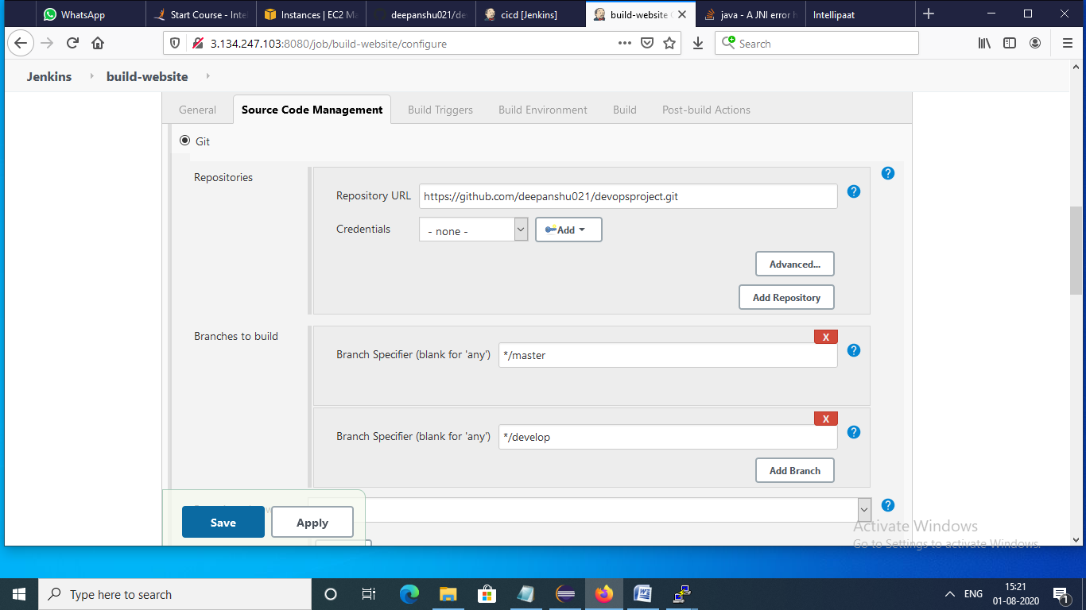

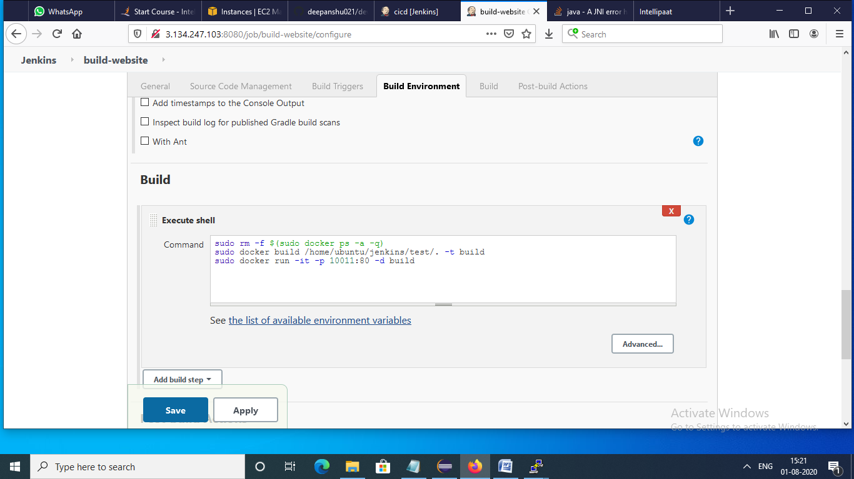

Configuration of build -sample webhook

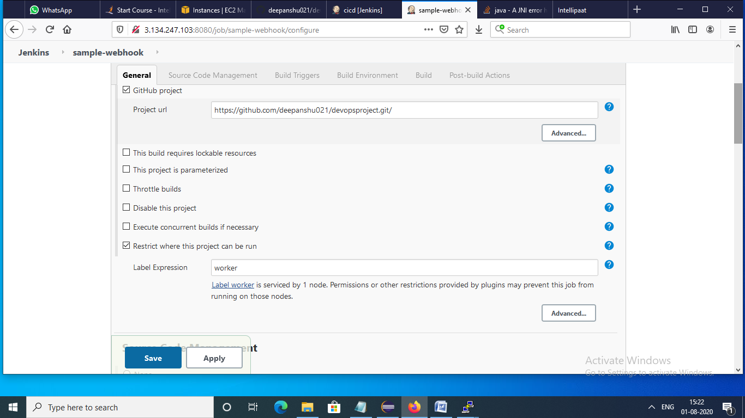

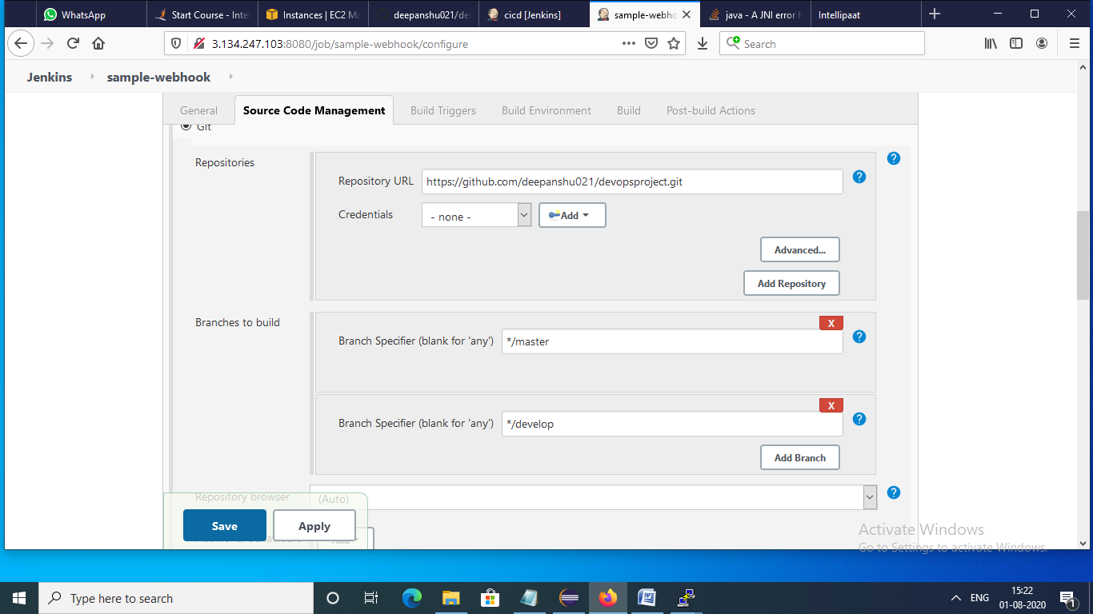

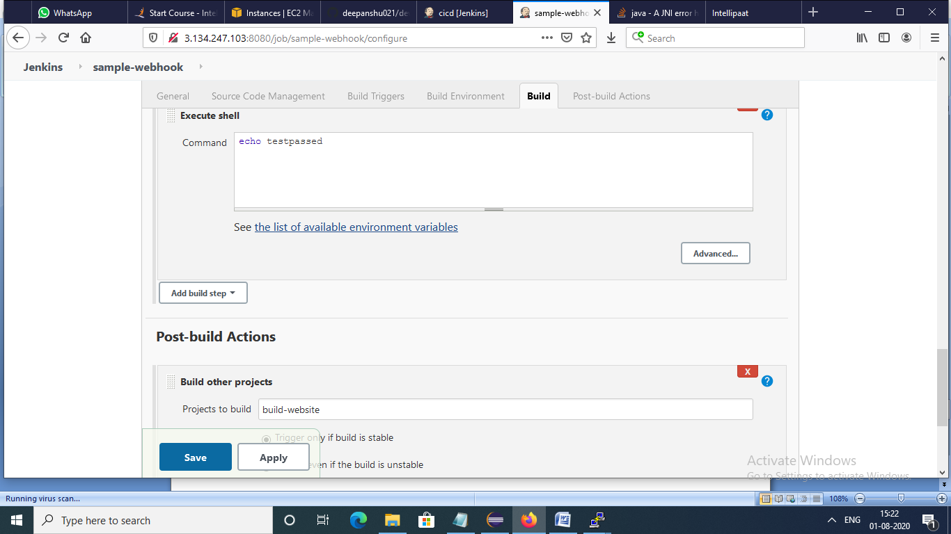

Configuration of build- test job

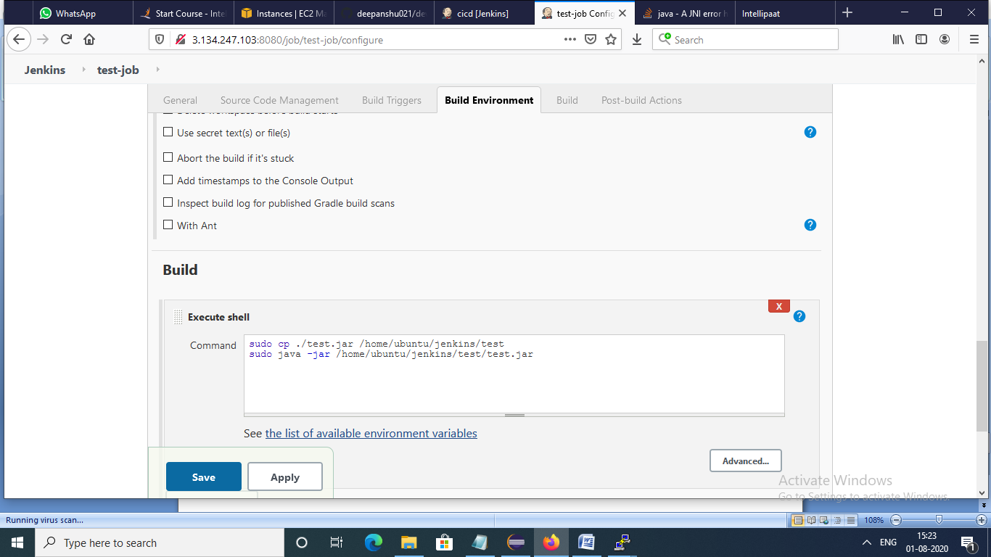

POM.XML file in eclipse

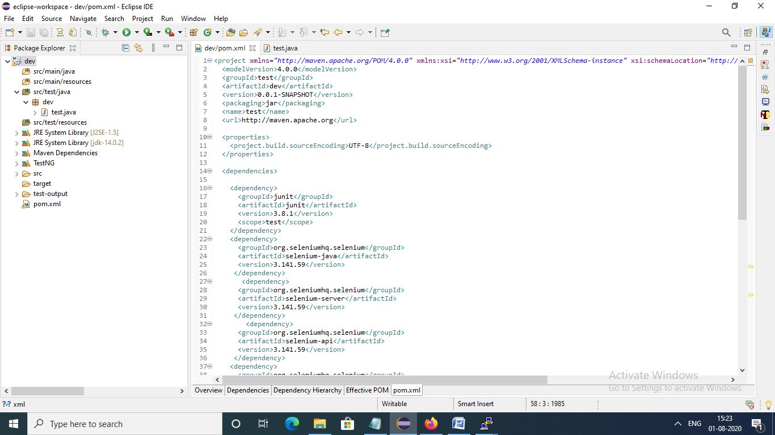

Test.java file in eclipse

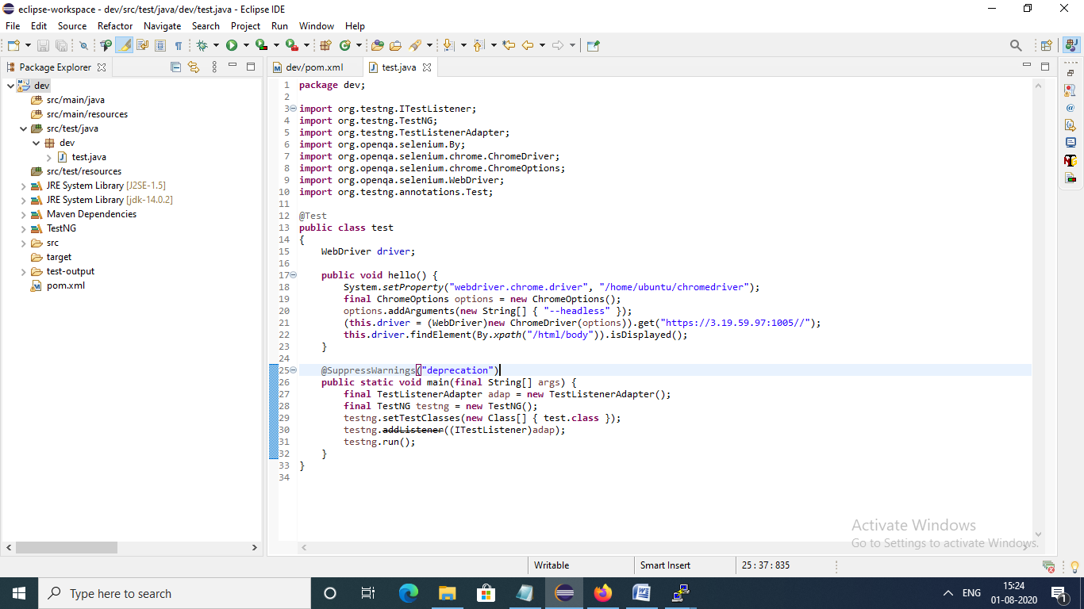

Successful build of website using dockerfile

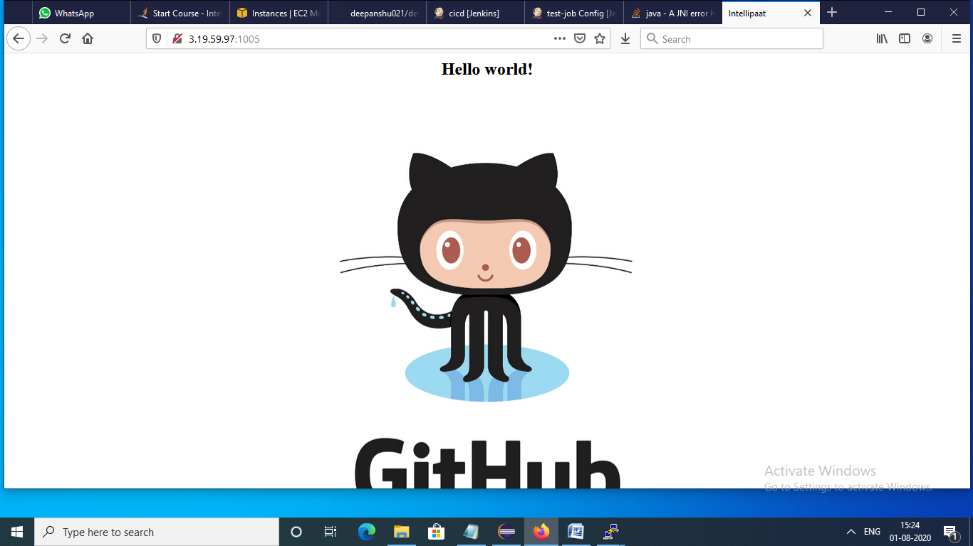

CICD pipeline

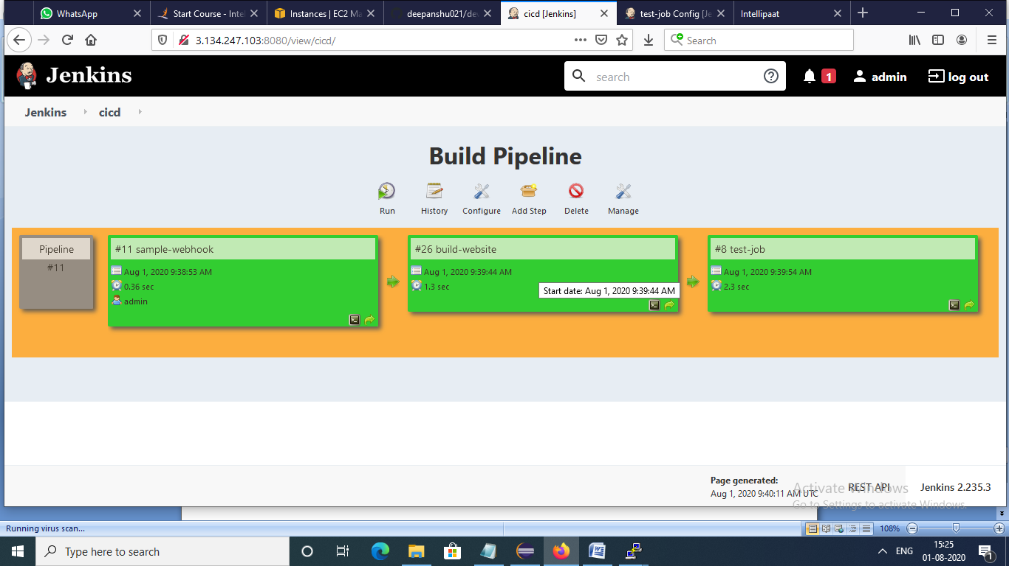

Production server starts

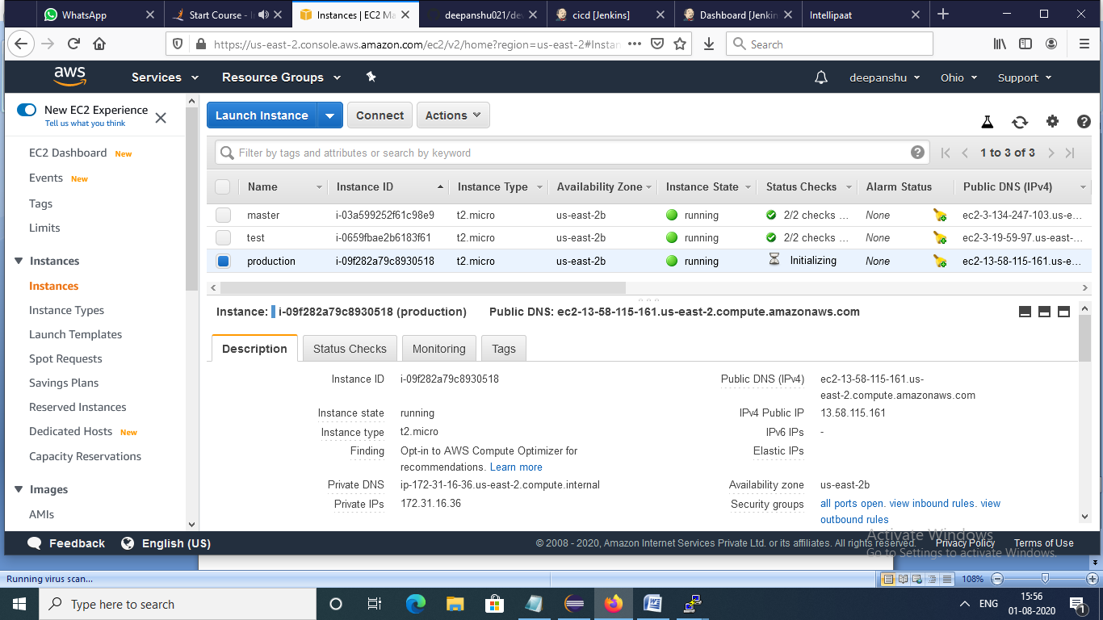

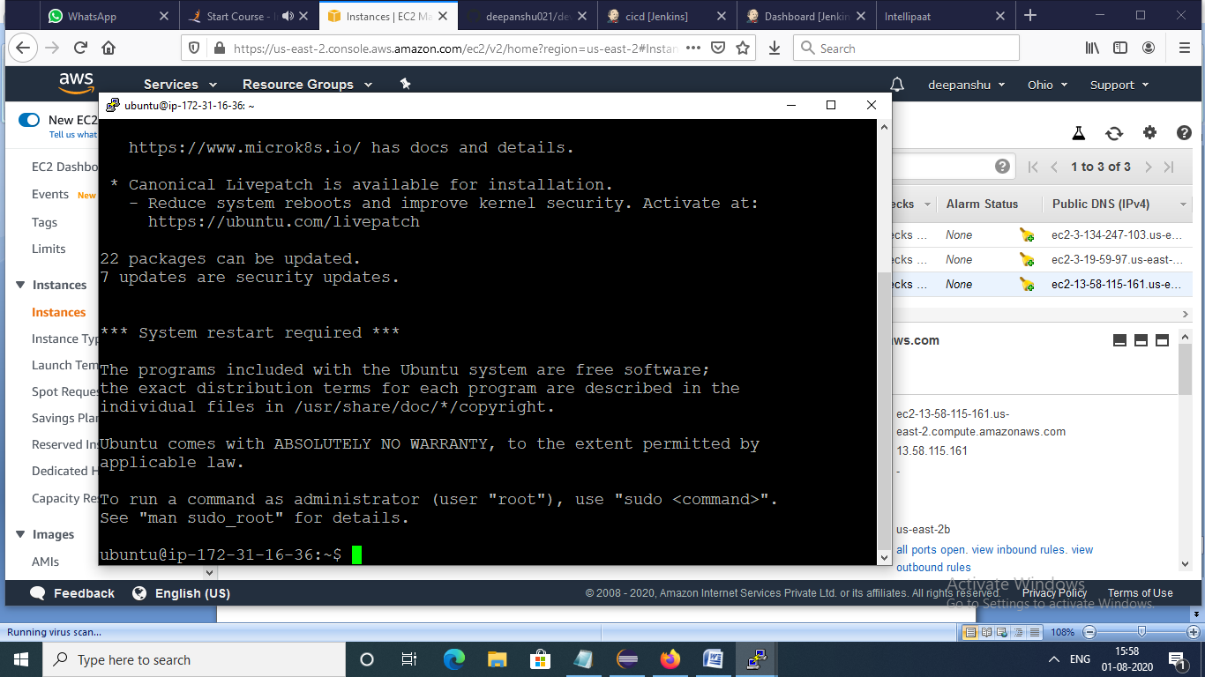

Production server connected with Jenkins as node using SSH

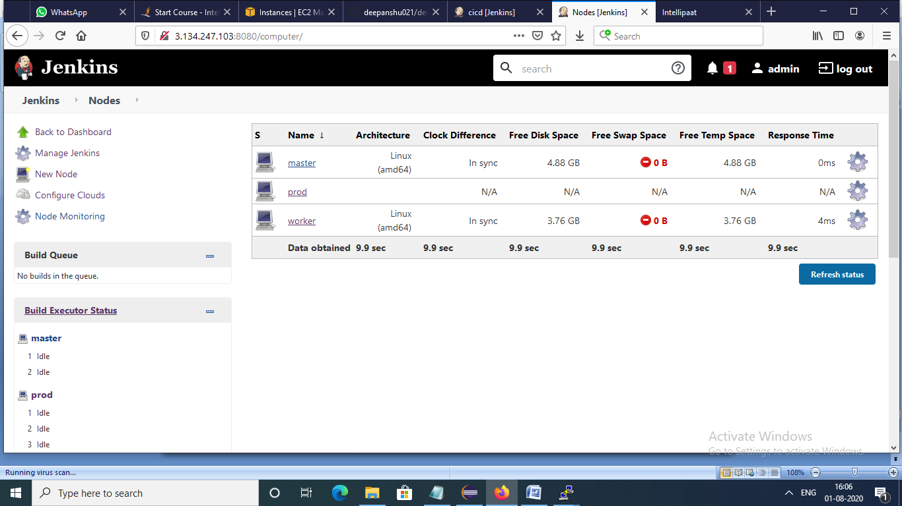

Configuration of production server

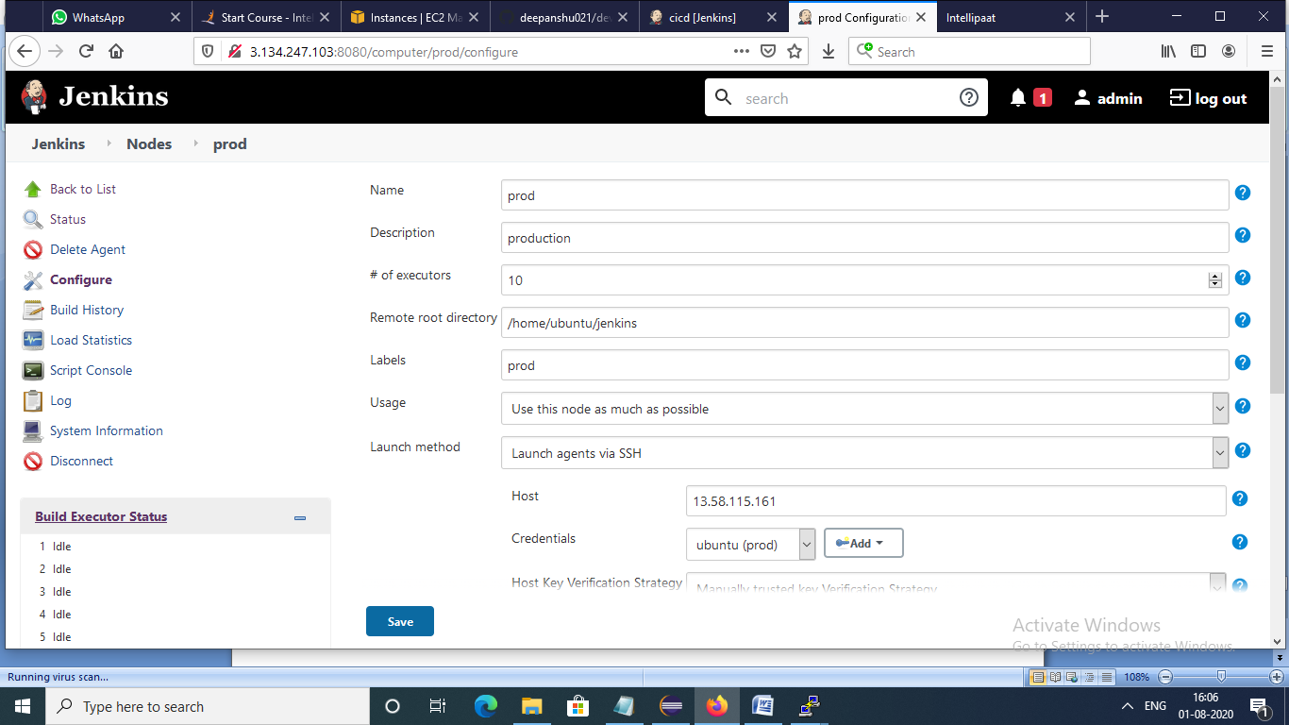

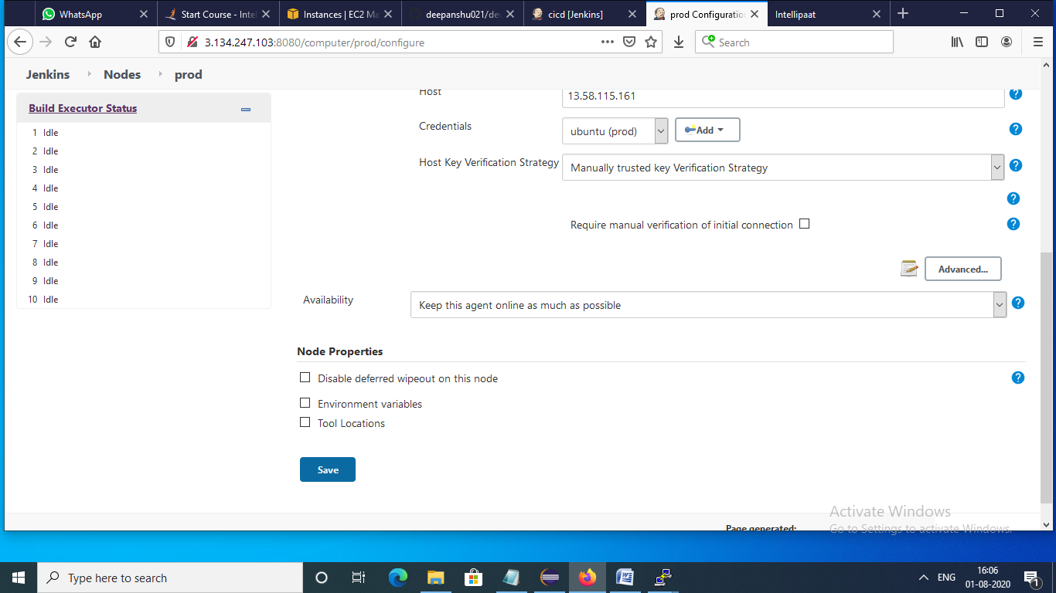

When production server connected with Jenkins all files automatically copied in production server

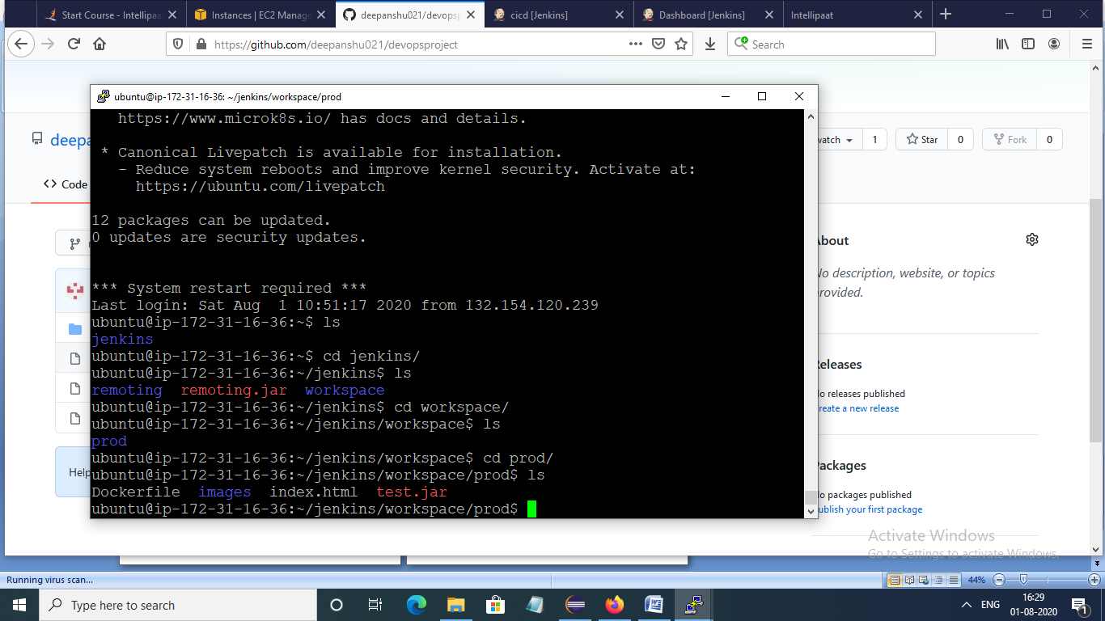

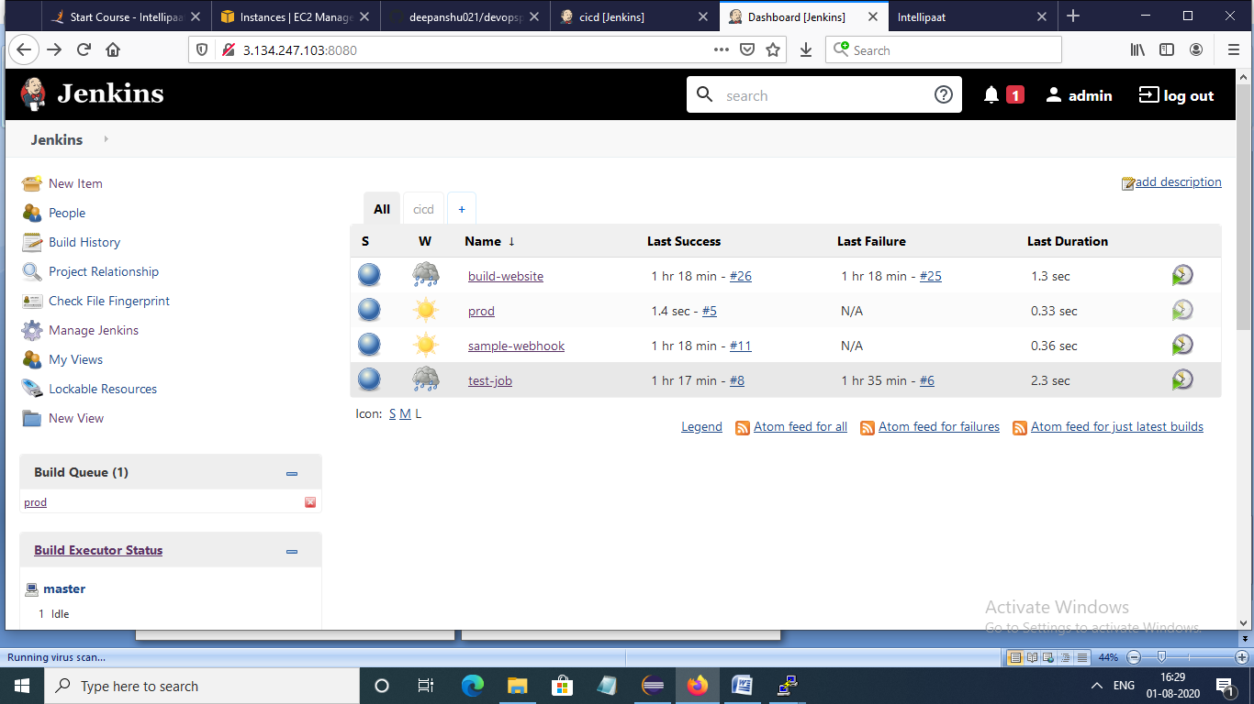

Successful build of CICD pipeline with production server

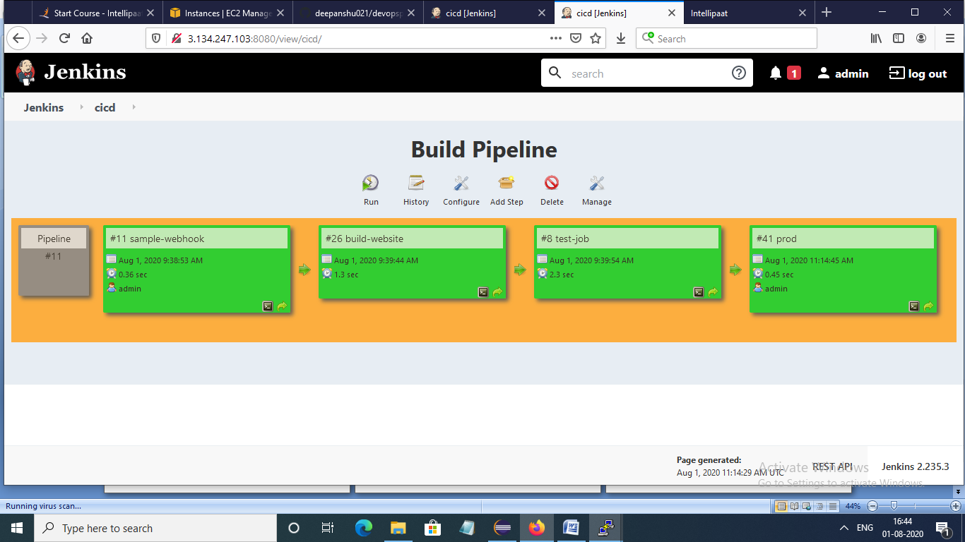

Configuration of production server

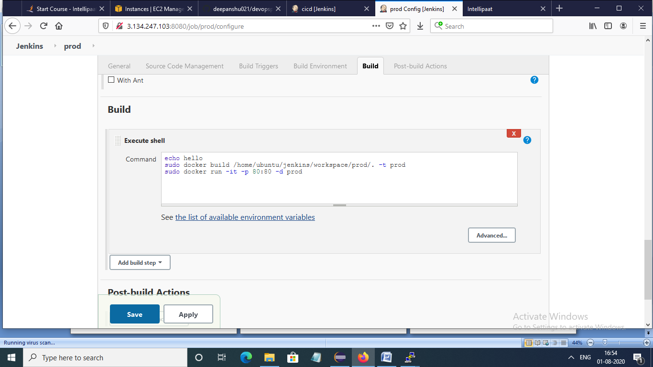

Website runs on port 80

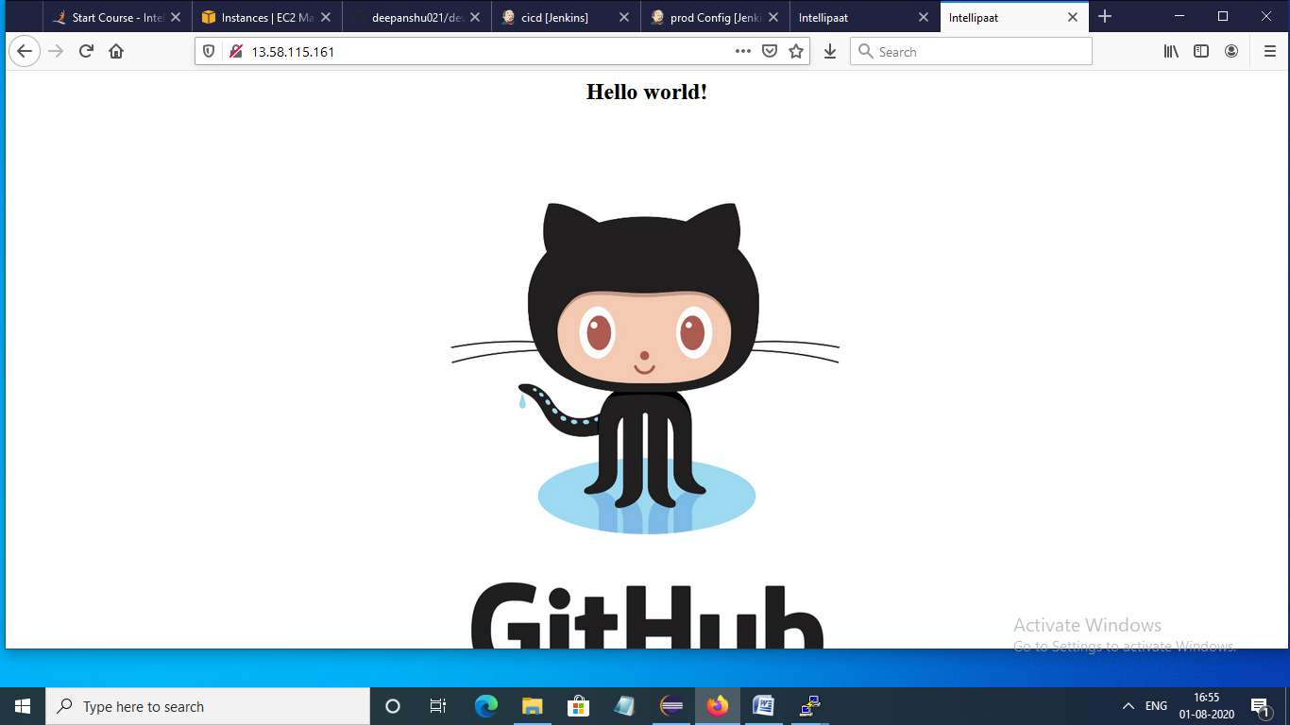

Installation of puppet master on master server

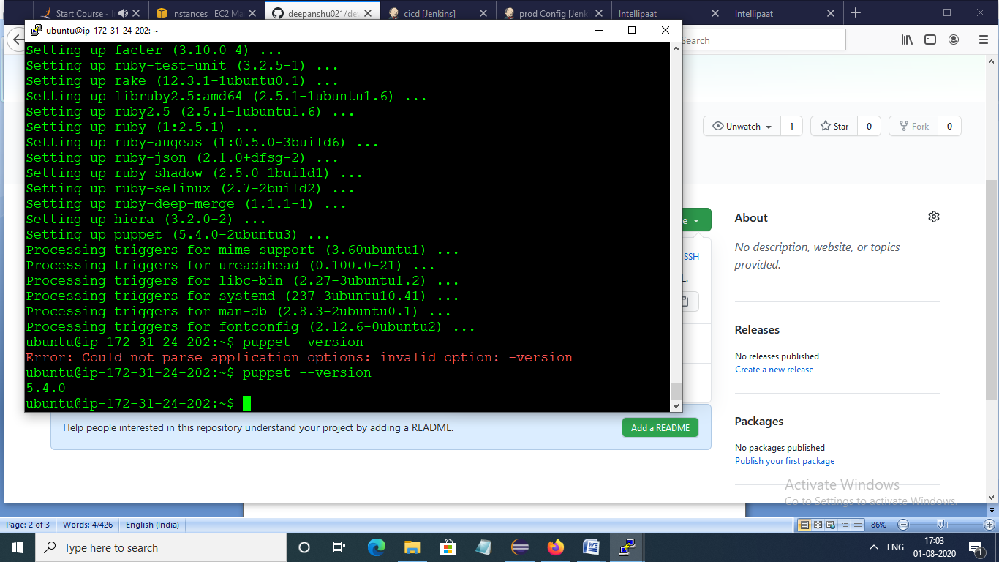

Configuration of master server fir apache2 using puppet

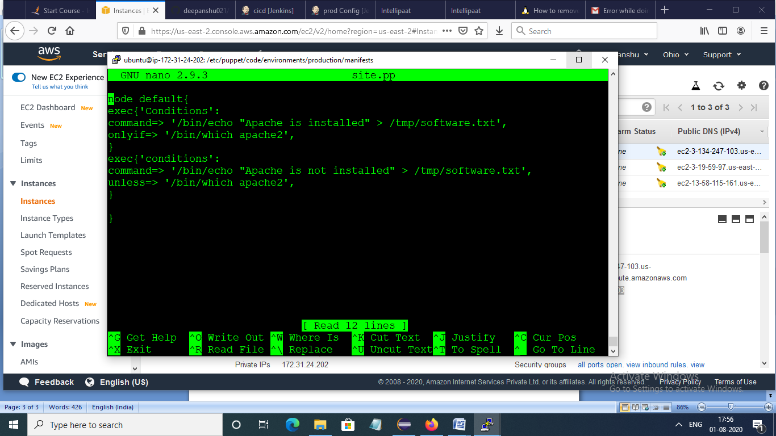

Test server showing puppet is installed or not

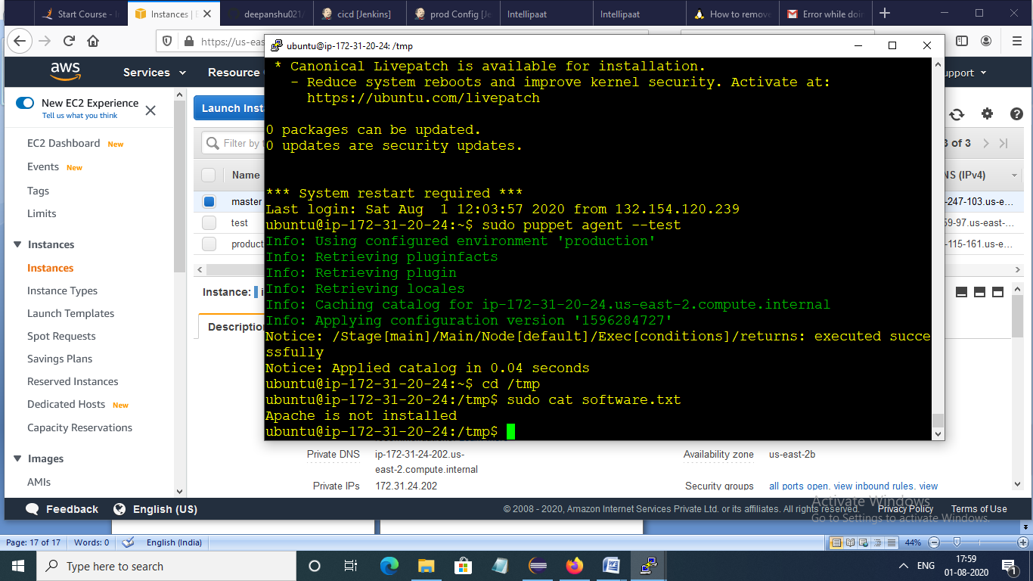

Production server with apache2 installation

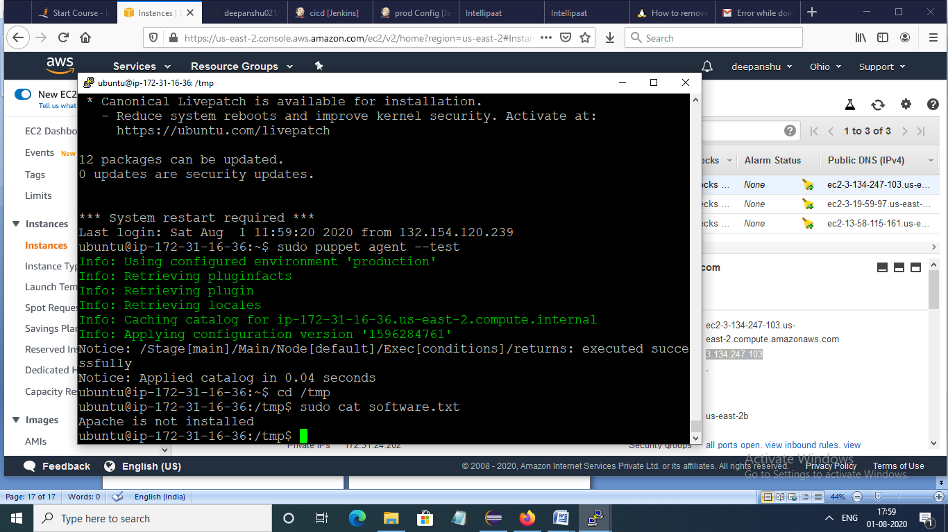

Installation of puppet on testing server

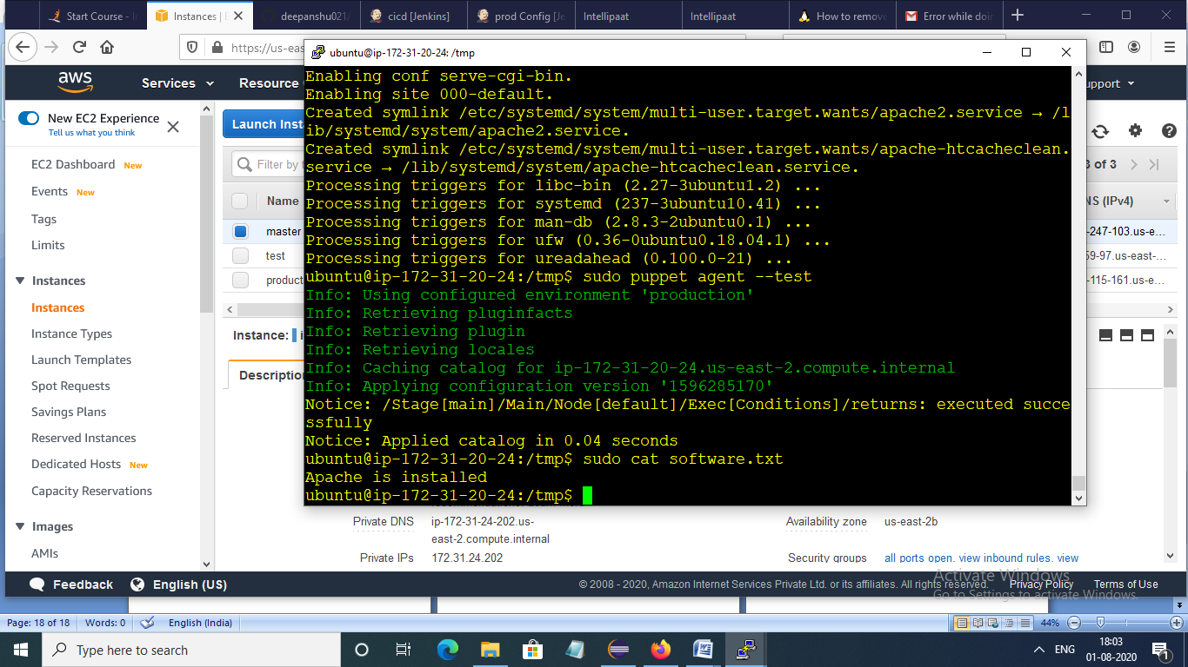

Installation of nagios on master server

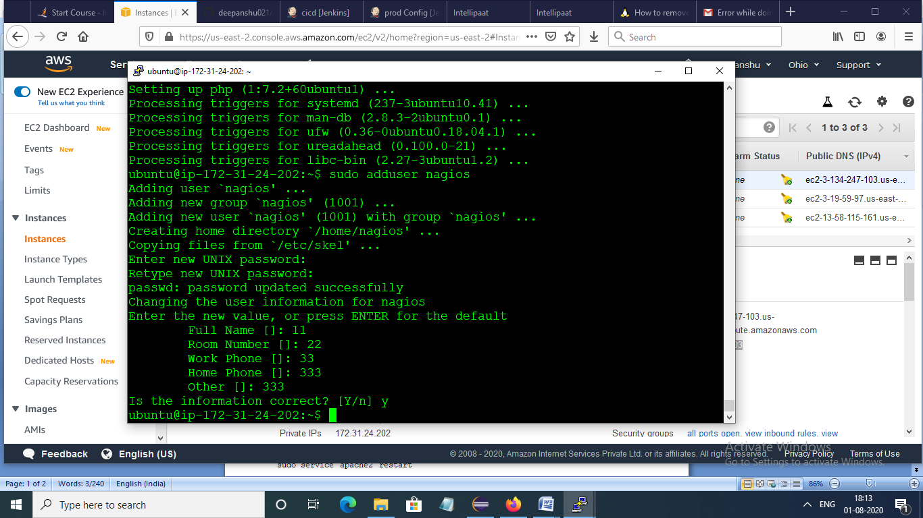

Nagios installed

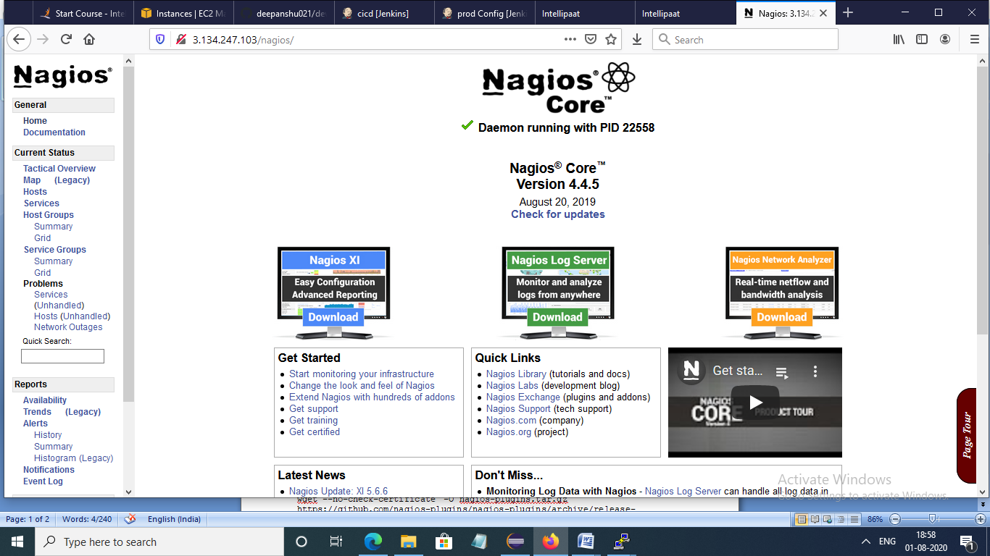

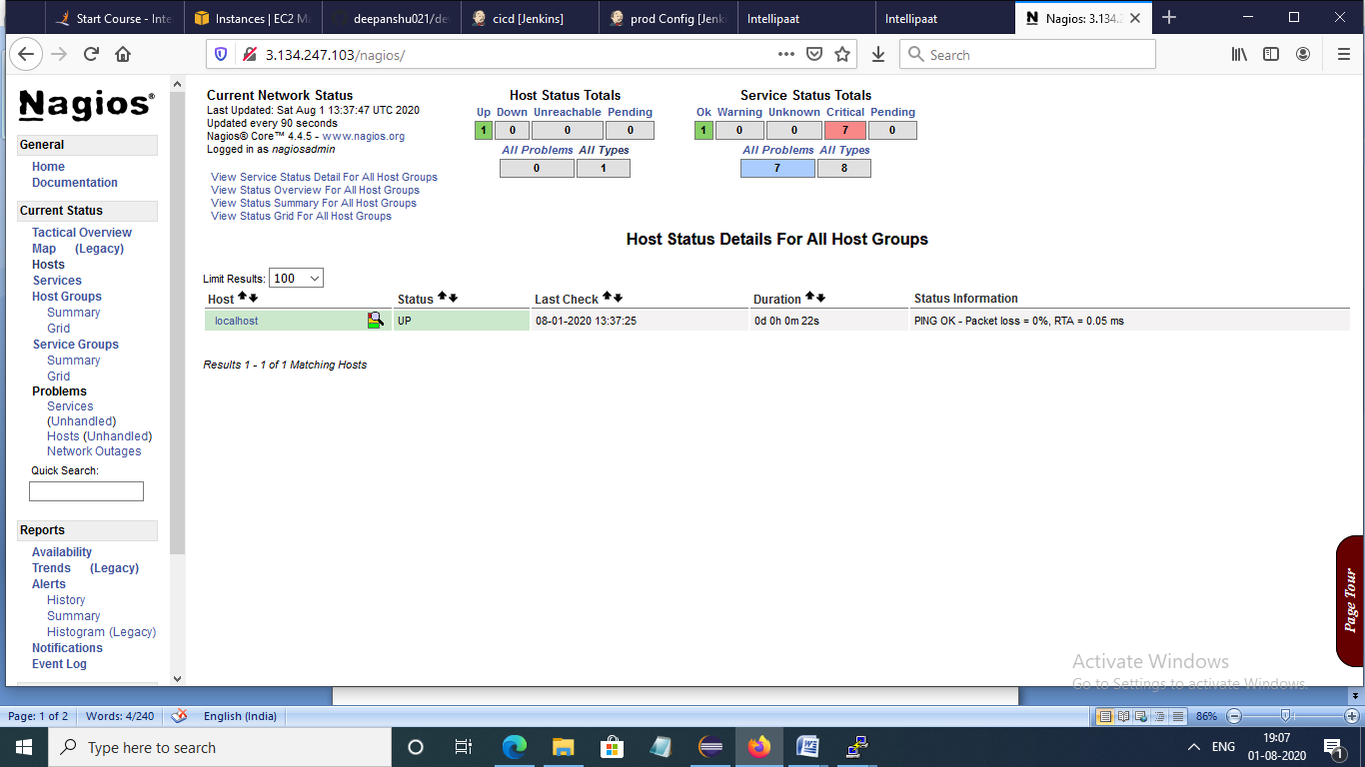

Configuration of nagios

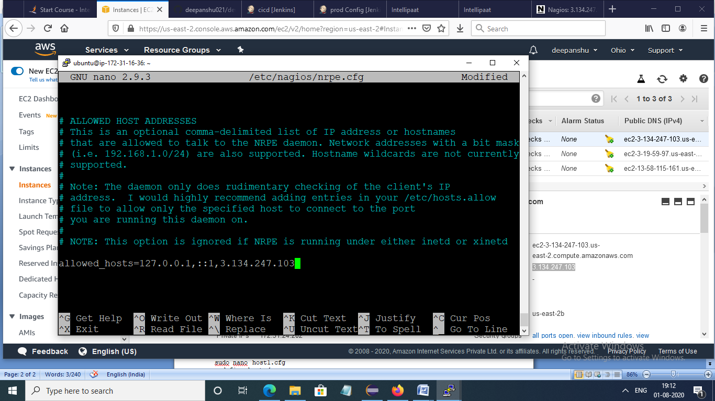

Connection of nagios with production server

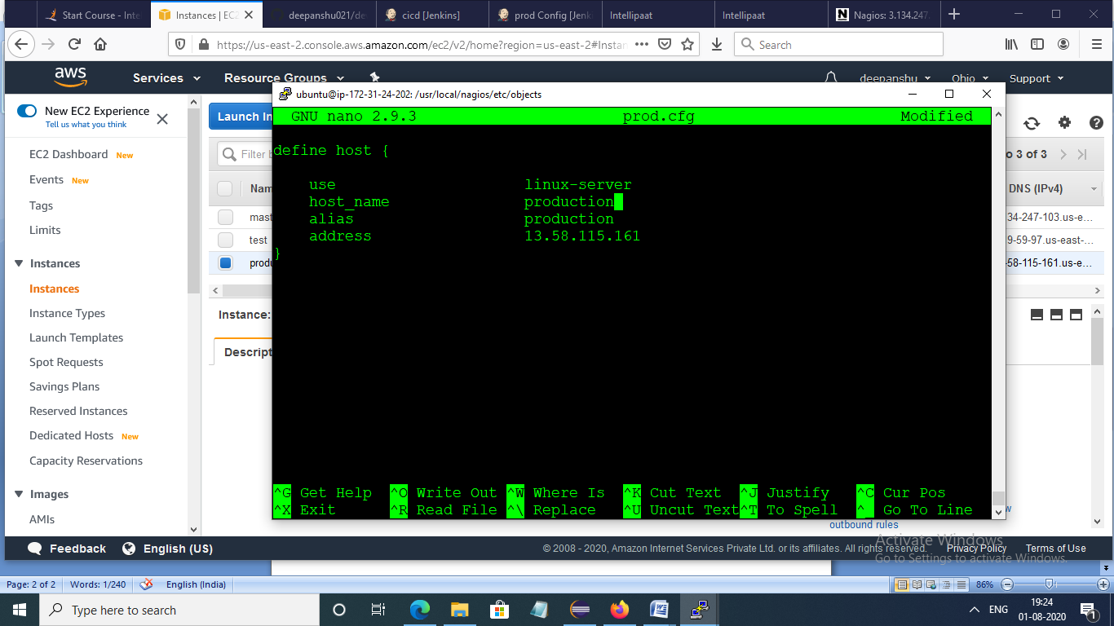

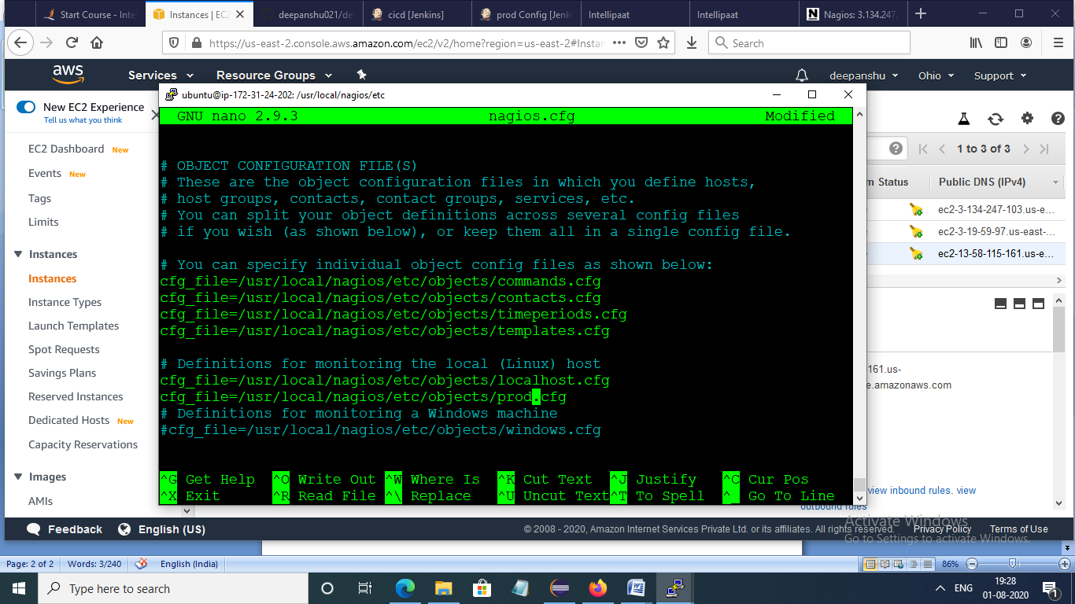

Production server up and running

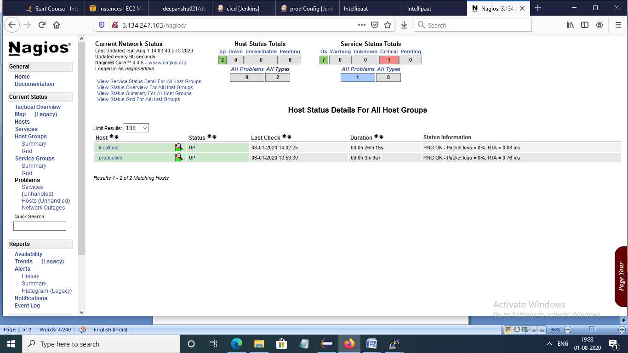

Removal of docker container port 80

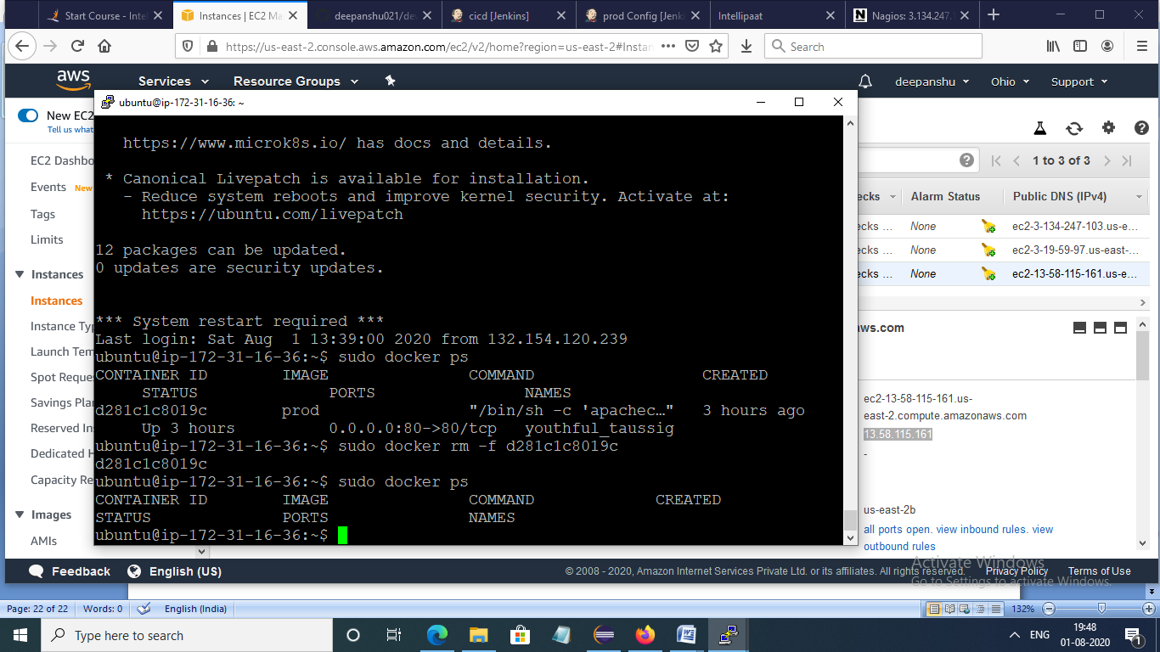

Website went down

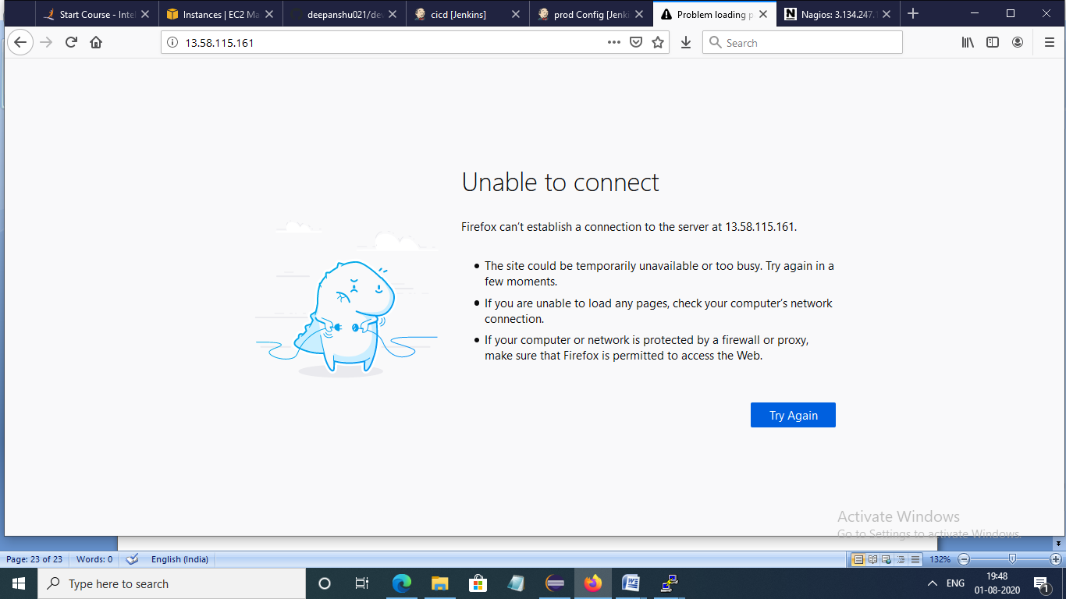

Creation of docker container on port 80

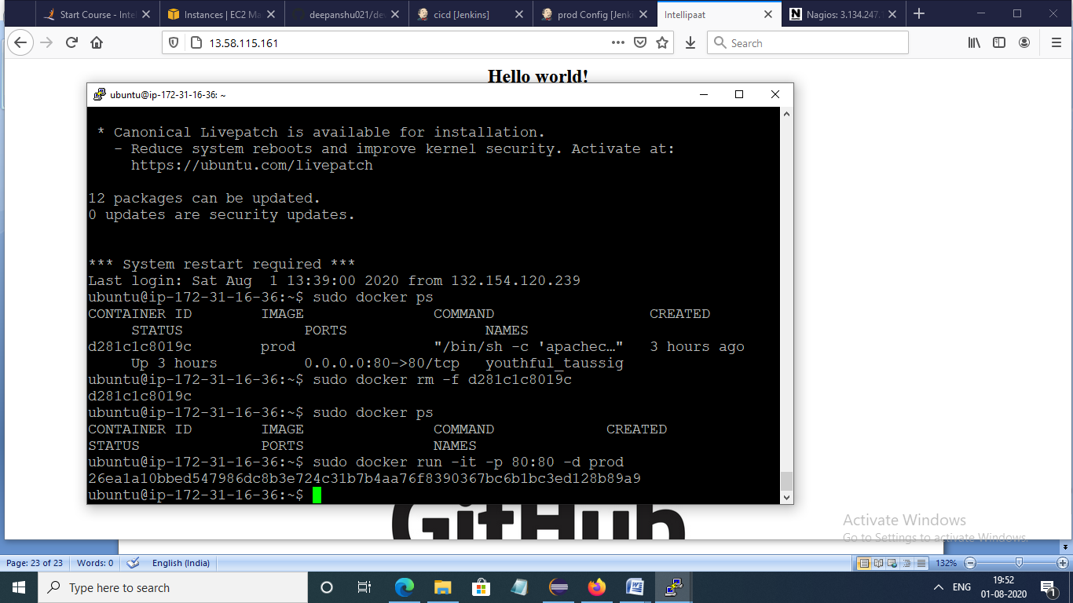

Website again pop up

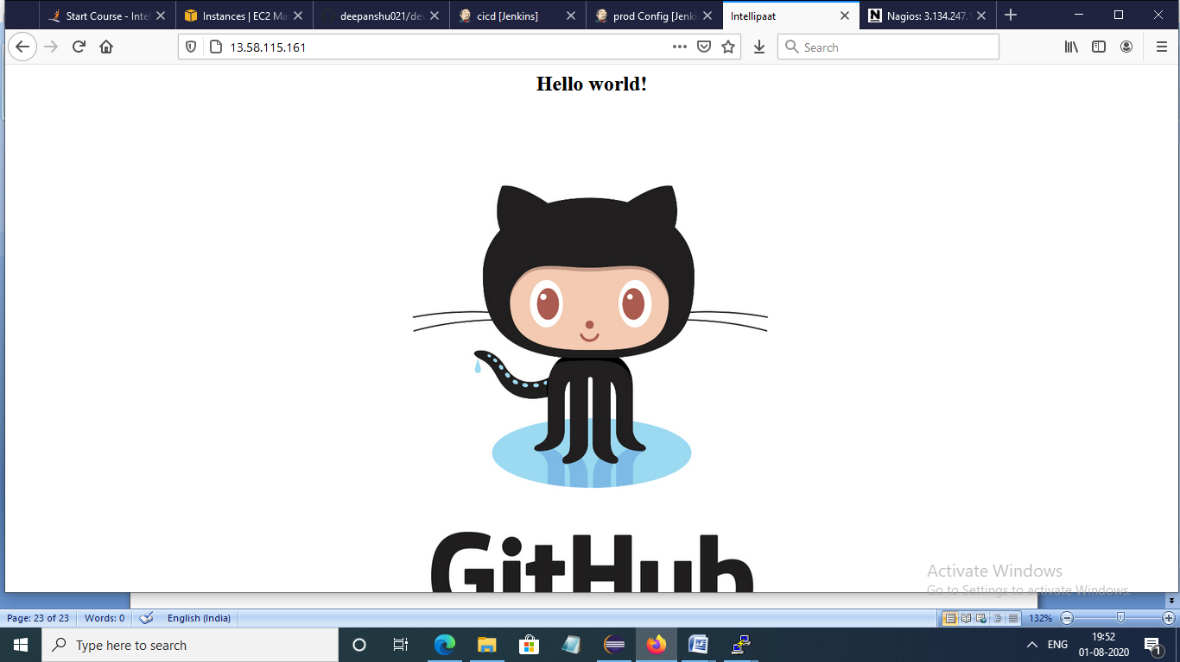

And monitoring server again up and running

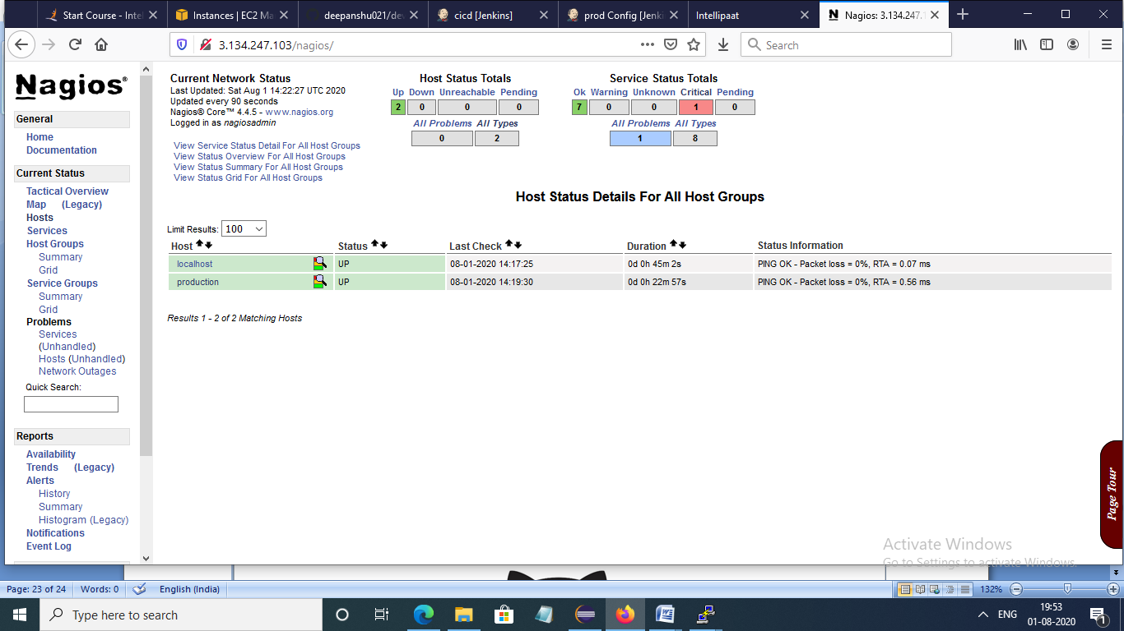

**THANK YOU**